Đoàn Trung Tấn

11THMT-1150080035

Lab6:

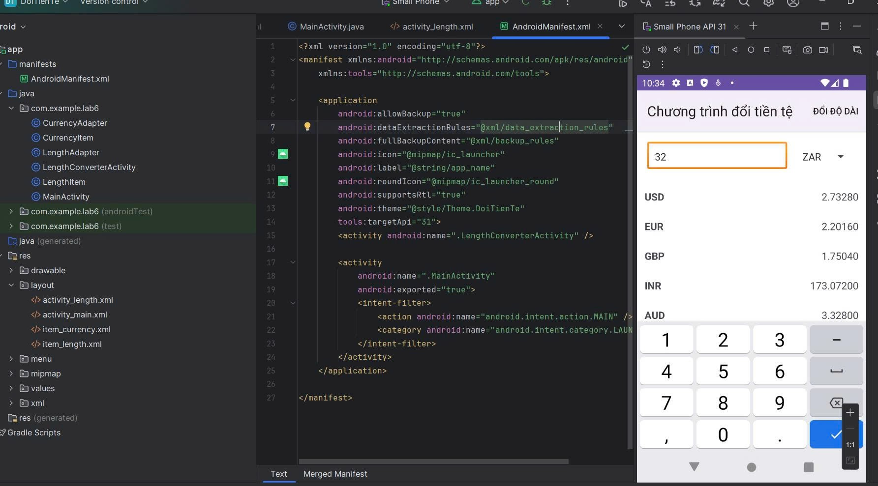

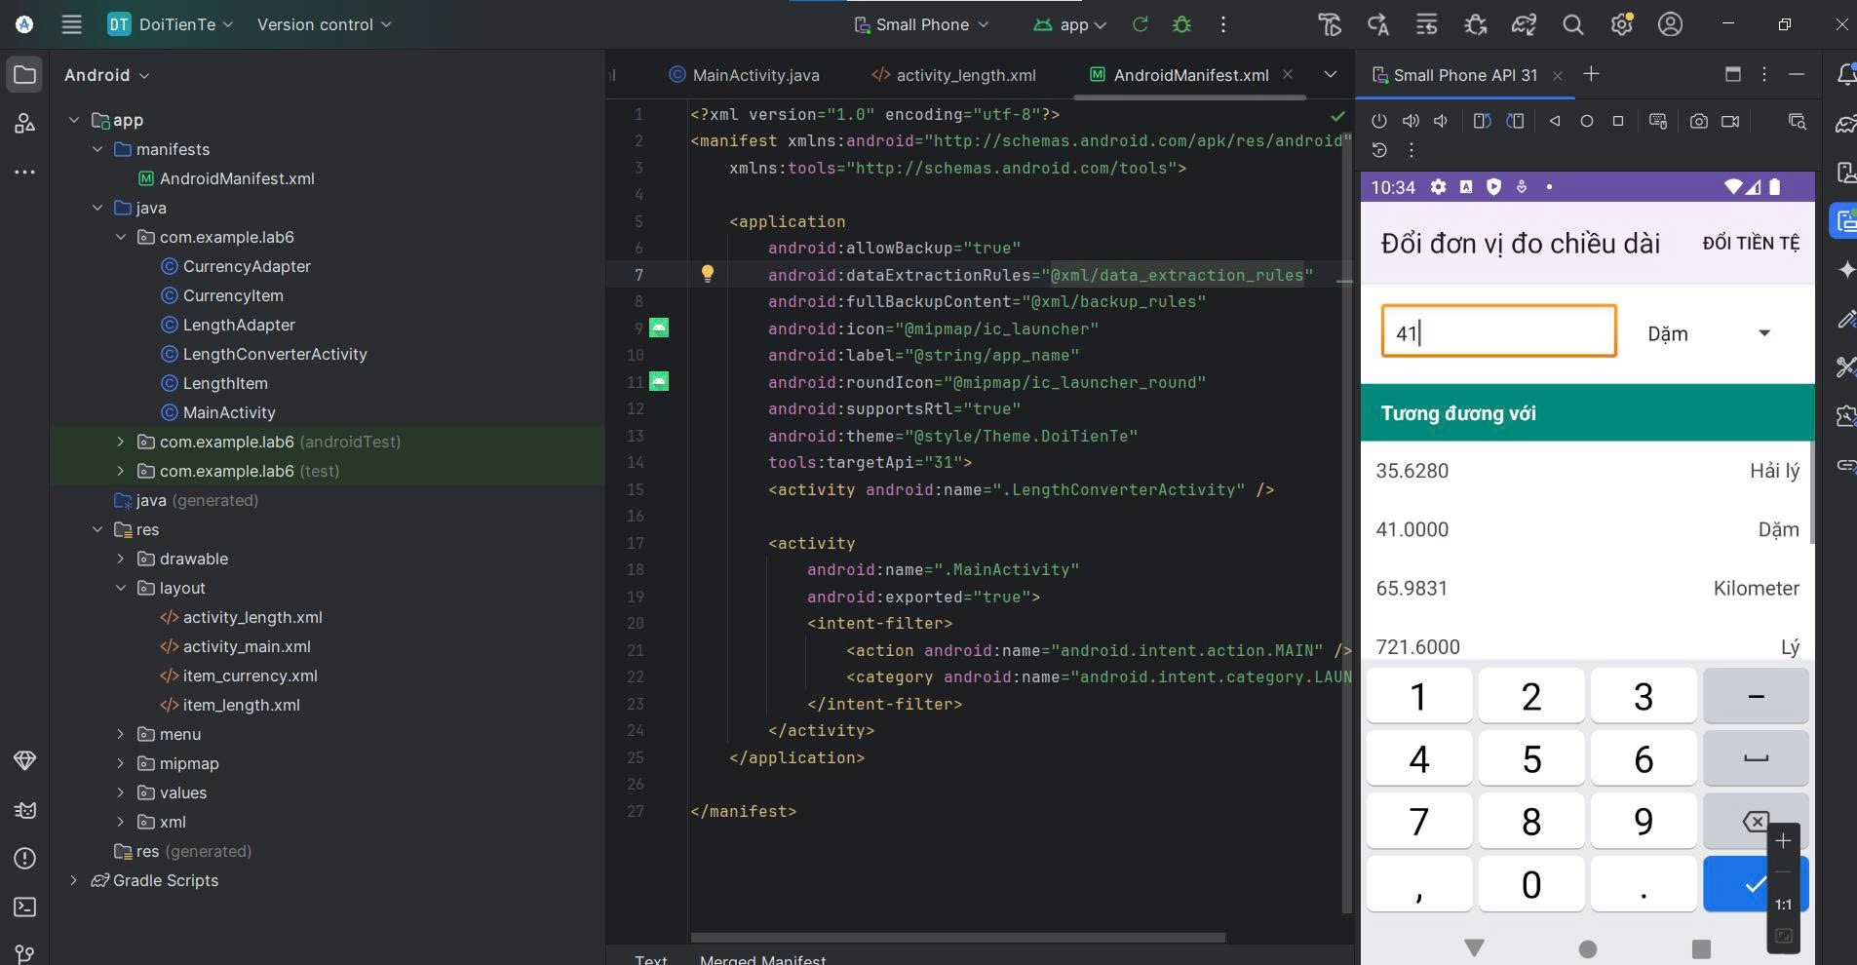

Lab7

Bài 1-2

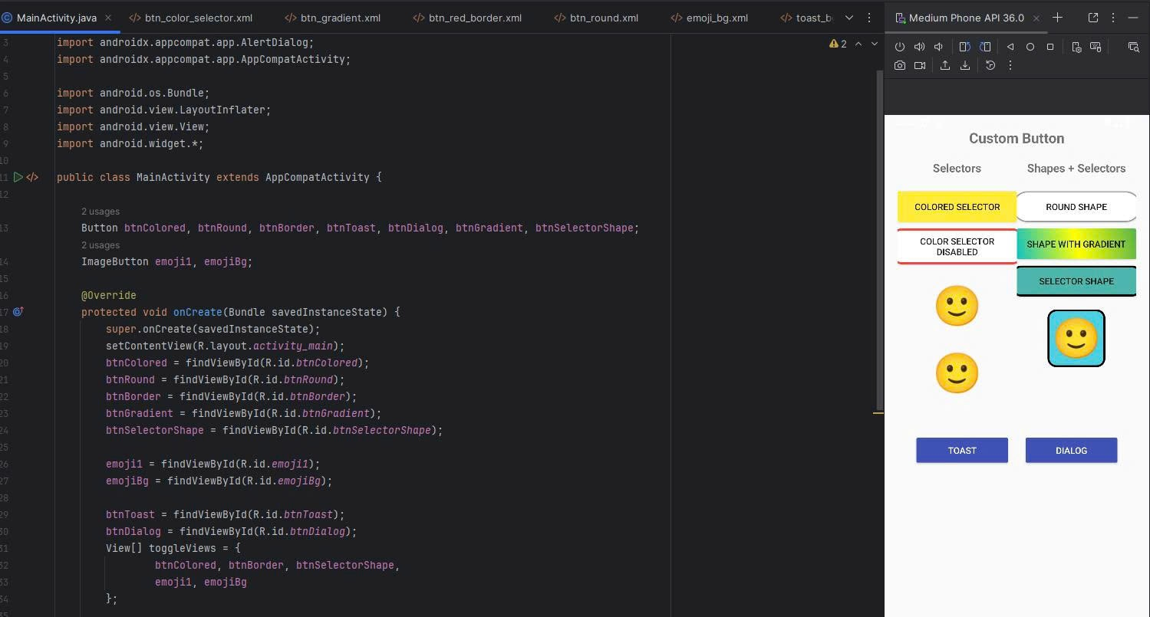

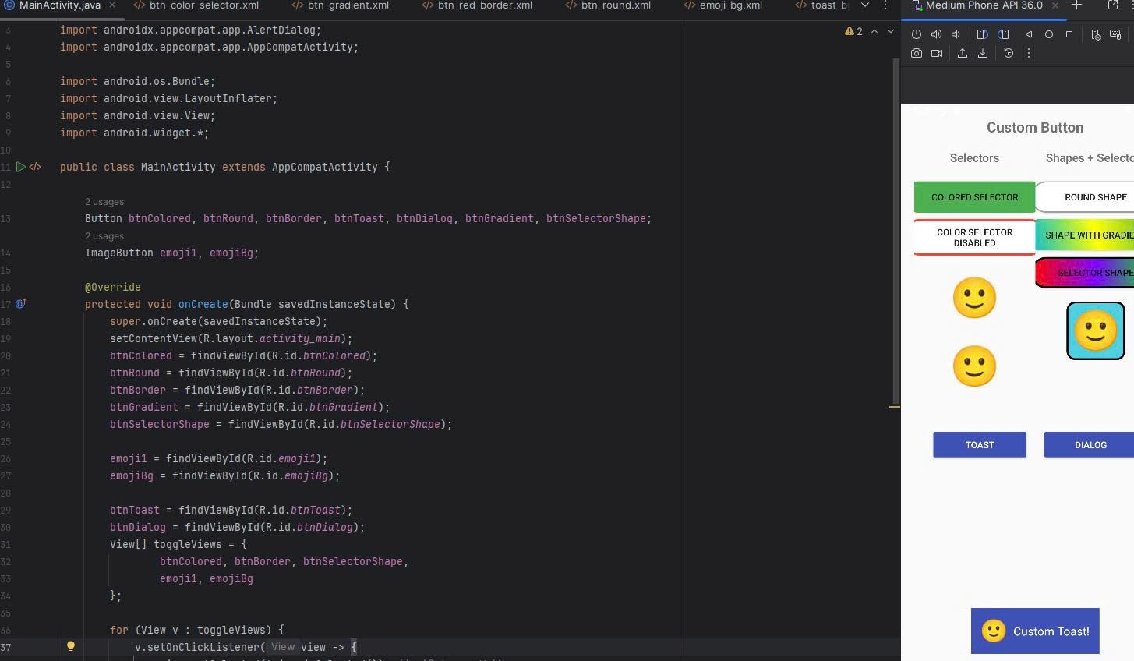

Lab7 Bai 3

